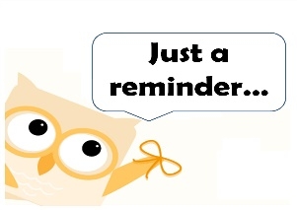

September 16, 2018

General Information:​

We had a great trip to the Safety Village on Thursday! We learned so many ways to keep ourselves safe. Take some time to talk to your child about all this great information.

Check the blog for some pictures from our fun day.

Thursday is Donut Day, you may purchase 1 donut for $1 or 2 for $2. Remember that all proceeds go toward the Rally Foundation for a cure for children’s cancer.  Thank you all for supporting Rally!

Thursday-ILC

Thursday- Guidance

What are we learning?

**Math**- Addition & Subtraction Word Problems and Money Word Problems  
**Reading/ELA**- Context Clues, Vowel Teams, and Review   
**Writing**- Personal Narrative (Small Moment Story)  
**Social Studies-**Regions, Rivers, and Government (Identify the need for rules and law. Identify elected officials of each branch and their locations.)  
**STEAM-**Regions Challenge

Don’t forget September break is coming!

September 22-30 Enjoy your time!

Also mark your calendars…Conference week is Oct. 15-19. Every day is early release.

Extra! Extra!

Read All About IT!