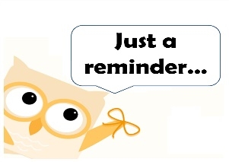

Extra! Extra!

Read All About IT!

September 10, 2018

Thursday 10/13 Safety Village Field Trip

We had a firefighter come talk to us to prepare for this trip. The kids were given homework. Talk to them about your meeting spot.

Try to get those Performing Arts permission slips in ASAP. Thanks!

I am attaching a link to the CCSD calendar just in case you don’t have <http://www.cobbk12.org/aboutccsd/calendars/2018-19/2018-19_Year-at-a-glance_Revised_180409.pdfit>.

What are we learning?

**Math**- Addition and subtraction strategies to help become more fluent  ​(Counting On, Making Ten, Counting Back, Decomposing, Balancing Equations) and problem solving.  
**Reading/ELA**-  Continuing to learn about story structure as well as understanding key details in a text. In phonics we will be looking at vowel teams to help us decode words.  We will be finishing up with collective nouns.

**Writing**-  Personal narratives; Small moment stories. We are working on writing with the senses.  
**Social Studies-** **Georgia’s geographical regions (Blue Ridge, Piedmont, Coastal Plain, Valley and Ridge, and Appalachian Plataeu. We will also be learning about the major rivers of Georgia (Savannah, Flint, and Chattahoochee).**  
**STEAM: TBD**

**It’s going to be fabulous week!!**

General Information:​

Can you believe we are already half way through our first nine weeks? Time sure flies!

We have a few things going on that I need to remind and update you on.

**Homework Bags: They started this week. Your child is checking out math games, and or books from the classroom. Make sure to play those math games. Transfer of skills is the best way to see that your child really understands a skill. Playing a game is so much more authentic than a worksheet. I have told the kids that they are only allowed to keep the game 2 nights before having to return it. Also, please make sure to keep the game pieces together and return all the pieces, marker included in the bag it came home in. ☺

**Library News- As you finish reading the books your child checks out of the ILC remember to send them back to school. We go to the ILC usually every week, and your child can go check out books in the mornings also.