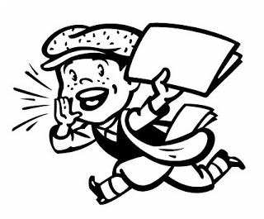
November 26, 2018
Extra! Extra
Read All About It!!
Wish List:
*Treasure box items
*Notebook paper
* New Crayons (24 pack Crayola)
We will get new supplies after the winter holidays, so we will need new crayons.
Schedule:
Monday: ILC
Thursday: Mrs. Grindstaff

General Information:
I hope you all had a wonderful week with your families and loved ones. Wasn’t it fabulous to have some time without alarm clocks?? I am hopeful you all ate way too much yummy food, and made so many wonderful new memories! I know the Wiggins family did!

I am excited to see your sweet children tomorrow morning! WE have a lot of work to do in our VERY short 4 weeks before our Winter Holiday break! We will be busy!

​ Here is what we are learning this week:
Math: Adding subtracting with place value strategies
Reading/Language Arts: Understanding points an author makes in a text. Students will try to determine the main point in a text and find reasons/details that support that point.
Phonics: We will review reflexive pronouns, and begin to focus on how apostrophes are used to form possessive nouns and contractions.
We will continue to explore vowel variant diagraphs and diphthongs (au,aw, ou/ow, oo/ew, oi/oy)
Writing: Informational
Science: Beginning Stars/Sun
Social Studies: finishing up James Oglethorpe, Mary Musgrove, Tomichichi

