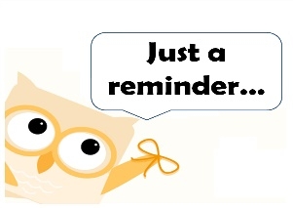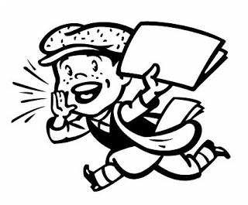

October 15, 2018

Wish List:

40/60 watt light bulbs

2 gallon sized Ziploc bags

What are we learning?

**Math**-   
**Reading/ELA**-Fiction and non fiction reading, Non fiction text features

**Writing**- writing cinquains (poems)  
**Science-** Seasons  
**STEAM: Review of 4 C’s, and the engineering process,**We will also be creating a poem and visual representation of a tree in the fall.

General Information:​

I am looking very forward to our time this week. I love sitting down and talking to you about how absolutely wonderful your children are! Please remember we only have 20 minutes, so being on time is important. I will also make a promise to try to stay on schedule as well. Please let me know you are at the door by ringing the bell, it will be magnetically attached to the door frame. That will be a good reminder for me to wrap things up. Also, remember that the book fair is going on this week. There is no other way for you to get great books your kids love than to visit the book fair! So many great choices!!! I previewed it Friday and the class will preview it on Monday. Make sure to stop by!!

Lastly, please remember that it is early release every day this week.

Conference Week is this week! Early Release every day!

Extra! Extra!

Read All About IT!